**Matlab Runtime - Download and Installation**

**Requirements**

* The only requirement is a 64-bit Windows operating system with at least 10 GB of available space.

**Download Matlab Runtime**

1. The zip file must be downloaded directly from Matlab at the following link: <https://la.mathworks.com/products/compiler/matlab-runtime.html>. Make sure to select the 64-bit R2020a (9.8) version for Windows.

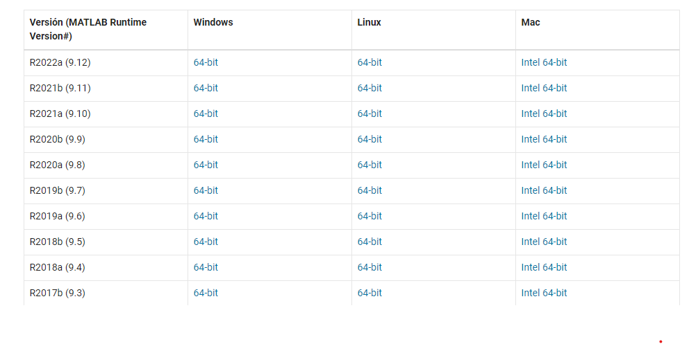

**Install Matlab Runtime**

1. Unzip the downloaded file.
2. Open the folder “MATLAB_Runtime_R2020a”
3. Double click on “setup”. This will start the Matlab Runtime installation process.
4. 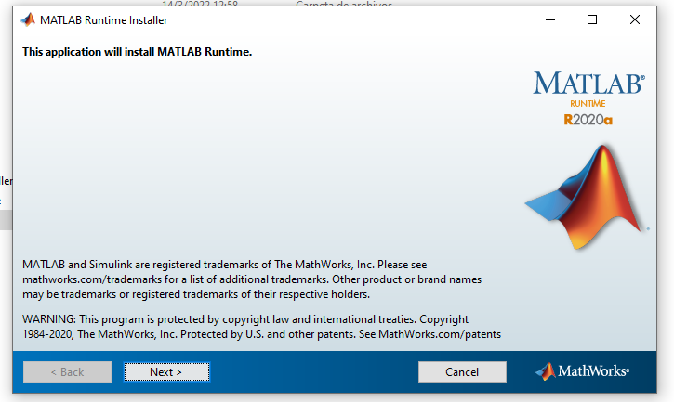Click on “Next”

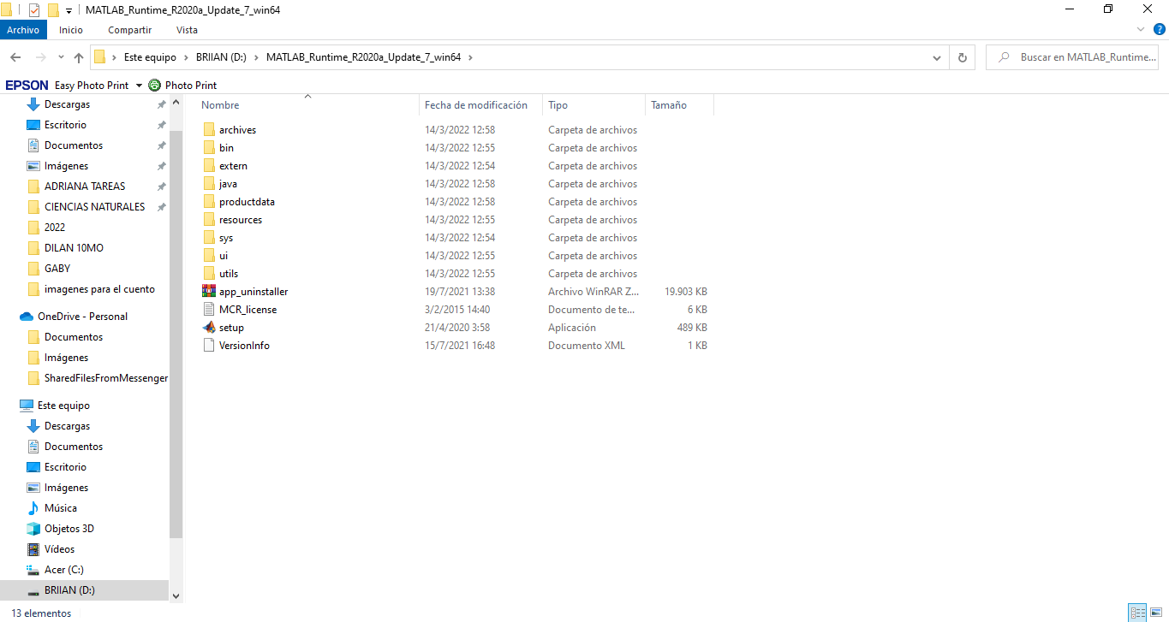

1. Then, accept terms and conditions and click “Next”.

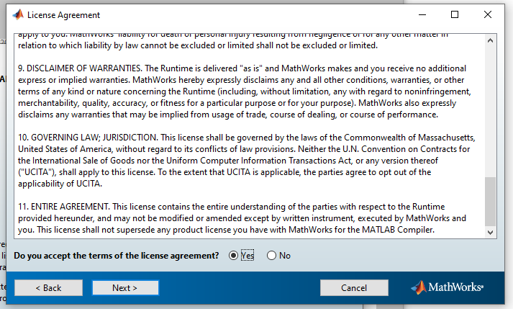

1. Choose installation folder and click on “Next”. (It is advisable not to modify)

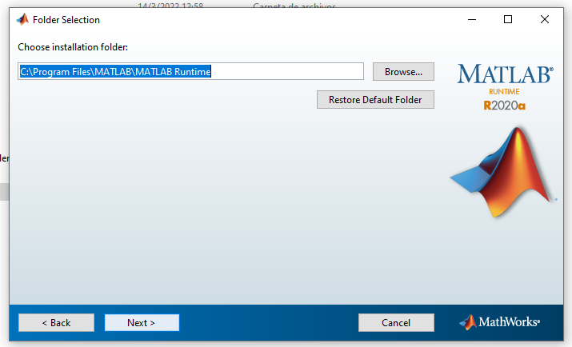

1. Verify the information and then click on “Install”.

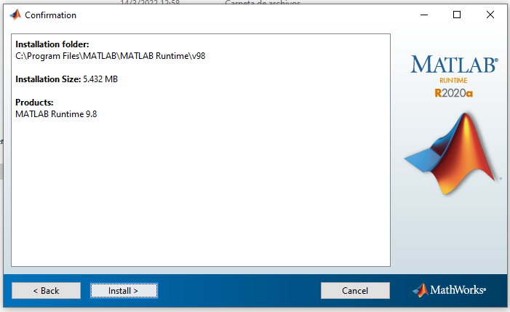

1. A bar will appear showing the installation in progress. Once the installation is complete, click on “Finish”.

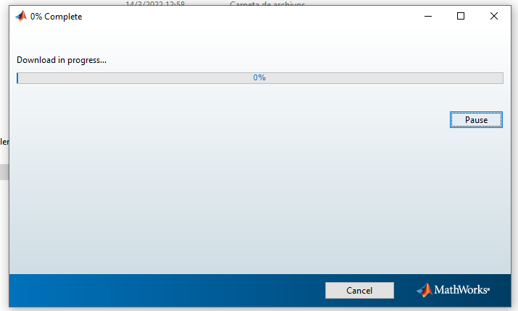

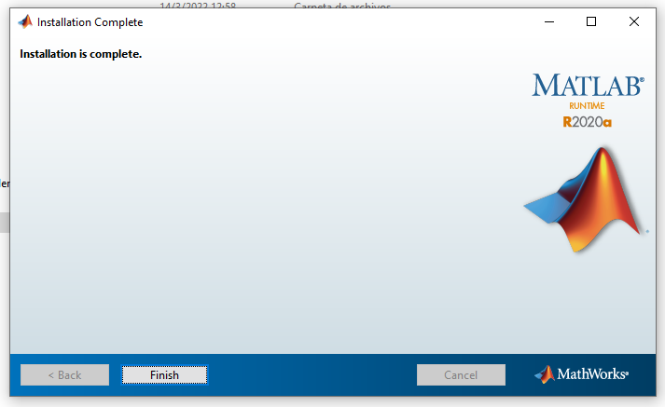

***\*Note:*** *Continue to folder 2: “GUSignal Download and Installation”*